Research Methods 2012
Data Analysis assignment
James Lamb (s0900191)
25 March 2012
Word count: 1194
Research question: ‘Supporting students in the Second Life classroom’

Introduction
This report considers the question of ‘Supporting students in the Second Life classroom’. For the purpose of this analysis, the ‘Second Life classroom’ refers to a space within that virtual world where students and teachers participate in a teaching and learning session. To begin, this report outlines the approach that was taken to data analysis, including the formulation of the research question. It then moves beyond analysis to interpret the data, before offering conclusions and suggesting areas for further research. The analysis and interpretation of the data used a flexible, qualitative approach influenced by the work of Dey (1993) and Robson (2011).
Analysis
The analysis used data from two interviews conducted in Second Life (SL). The analysis commenced with an initial reading of the transcripts in order to get an overall sense of the data. A second reading then took place with line-by-line notes being taken (see Figure 1). The purpose of these preliminary exercises was to offer a holistic overview to help formulate a research question, which in turn helped to identify the most salient information.
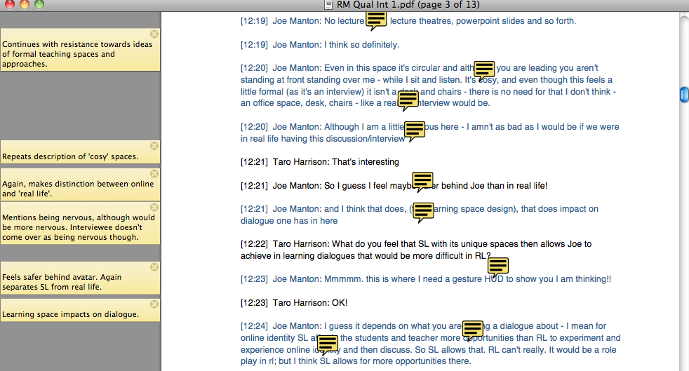
Figure 1. Screenshot of line-by-line notes of Joe’s interview transcript
A more explorative approach was then taken by mapping the data using brainstorming software bubbl.us (see Figure 2 below and Appendix 1). The visual representations offered a different perspective of the data, identifying patterns and highlighting some common themes both within and across the two interview transcripts.
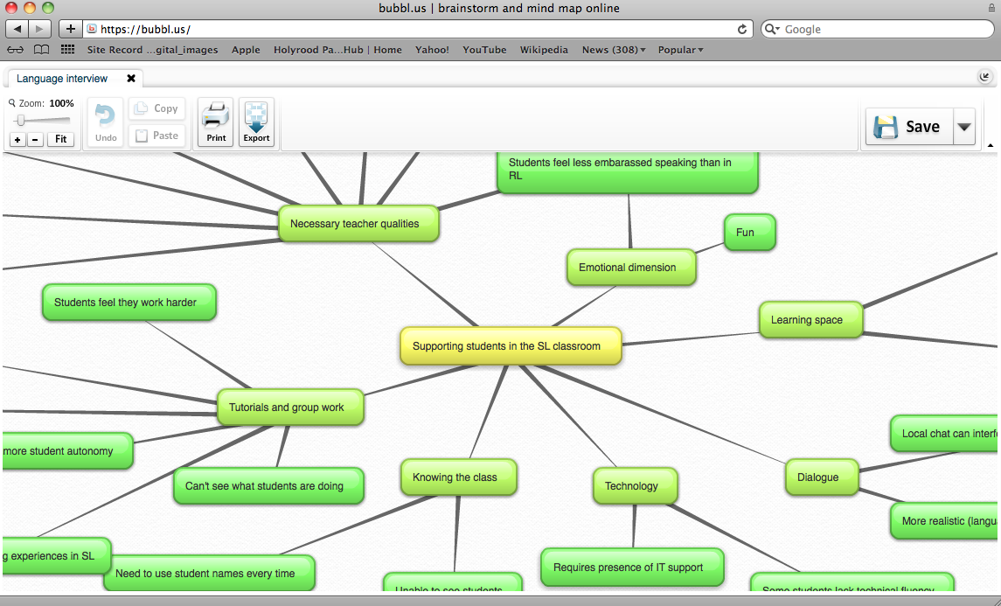
Figure 2. Screenshot Kirsty’s interview being mapped
The next stage of analysis was to input the themes that emerged in the mapping exercise into the HyperRESEARCH qualitative analysis software. The most relevant items of data from the mapping exercise were then inputted as codes under these groups. As Appendix 2 demonstrates, the coding exercise took a realist stance, with the emphasis upon description and meaning making by participants.
After a period of moving backward and forward between the research question and the data, the selection of codes was reduced to disregard information that, although of relevance to the topic of SL, did not address the question directly (although future research could explore how presence and immersion in SL could impact on student support). Nevertheless, the omission of this data prevented the exercise from becoming unwieldy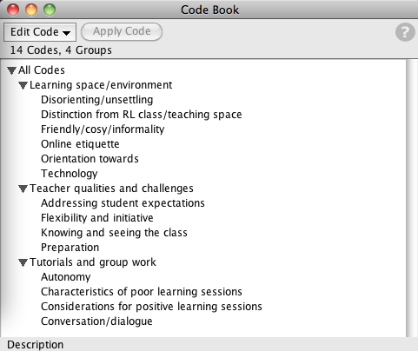Diagram 3: Codes and Groups created in HyperRESEARCH

It should be noted at this stage that although the creation of themes and codes was based on inferences from the data and with a view to addressing the research question, the researcher’s existing personal experience and knowledge of literature on the subject also helped to inform the process. As such, the creation of themes was empirically and conceptually grounded, whilst also being guided by the research question.
Interpretation
The HyperRESEARCH analysis highlighted a number of consistencies between the two interviews in relation to supporting students in SL. Both participants emphasised the importance of recognising the distinct characteristics of the SL classroom, even if students were initially unaware of how the class might differ from real life (RL):
Kirsty Salvesen: ‘Well, the first day some students expected to see a board for example which I found strange because everything is written down. They also expect more of a linear way of working you do A and then B. They also expected me to correct them on the spot more often.’

Despite consistency in recognising that the SL classroom had its own affordances and challenges, it was interesting to note that the participants conceptualised the SL learning environment in different ways. Whereas Kirsty was entirely focused on practical approaches to supporting learning (how to facilitate group work, how to monitor activity in class), Joe considered in addition the symbolism of the learning space and how the atmosphere could be shaped to promote learning:
Joe Manton: ‘For me I have avoided buildings at all costs! I am trying to provide a space that one feels comfortable in as a learner - a space where you would visit even outside "class time" - one that is hopefully inviting, warm, friendly - without bricks!’

The different ways of framing the SL classroom here is important in discouraging us from assuming that a single approach to student support might suit every situation. Nevertheless, there was agreement that the distinct nature of the SL classroom required additional (teacher) preparation time alongside a flexible approach within class. For instance, Kirsty described the challenge of dealing with interruptions and latecomers:
Kirsty Salvesen: ‘You also have to explain or ask someone to explain via IM what they have missed, so you have to divide your tasks on the spot much more often.’

Both participants cited the challenge of helping students to recognise how to participate effectively during group discussion, for instance the ‘online etiquette’ of allowing a fellow student to finish talking (or typing) before putting forward an idea. On a related note, both participants described how the nature of dialogue and communication had a significant impact on the nature of group work:
Joe Manton: ‘Well as I said - and just as I did and we've been doing - one needs to wait for another person to finish typing before coming in, otherwise it's chaos. If a tutorial discussion is taking place it needs to be in small groups - like 4-5 or so.’

It was interesting to note how the two participants suggested this might be addressed. Joe repeatedly emphasised the necessity of an induction at the beginning of the course, however there was no mention of this within Kirsty’s interview, more an acceptance that students might require additional nurturing within class. Further research might explore attitudes towards induction as a means of supporting students.
Referring back to the research question in a more general way, the themes emerging from the data suggest that in order to support students in the SL classroom, the teacher needs to rethink her role (compared to in RL) with an extra focus on nurturing and facilitating discussion rather than traditional instruction.
Conclusion
This analysis has highlighted a number of approaches that could support students in the SL classroom. It is apparent from the data that recognition of the specific challenges and affordances of SL (and its distinction from the RL classroom) can be valuable when planning student support for this learning environment. Clearly, teachers have a key role to play in providing this support and this might require extra preparation before learning sessions and a more flexible approach within the classroom. The nature of discussion and interaction within SL also merits consideration and potentially some form of induction for students who are new to the environment.
The small scope of this exercise limits the actionable potential of these conclusions, however a larger data sample (including some qualitative data collection, perhaps through an online survey) might produce findings that could help new and existing teachers to support students in the Second Life classroom. In addition a broader analytical exercise might examine topics such as presence and immersion, themes that emerged in this exercise but were outside the direct focus of the research question.
References
Dey, I. (1993) Chapter 7 - reading and annotating (PDF) Qualitative Data Analysis: A User-Friendly Guide for Social Scientists. London: Routledge. [ebook].
Dey, I. (1993) Chapter 8 - creating categories (PDF) Qualitative Data Analysis: A User-Friendly Guide for Social Scientists. London: Routledge. [ebook].
Robson, C. (2011) Real world research : a resource for social scientists and practitioner-researchers. Chichester: Wiley
Appendix 1a. A visual representation of Kirsty’s interview
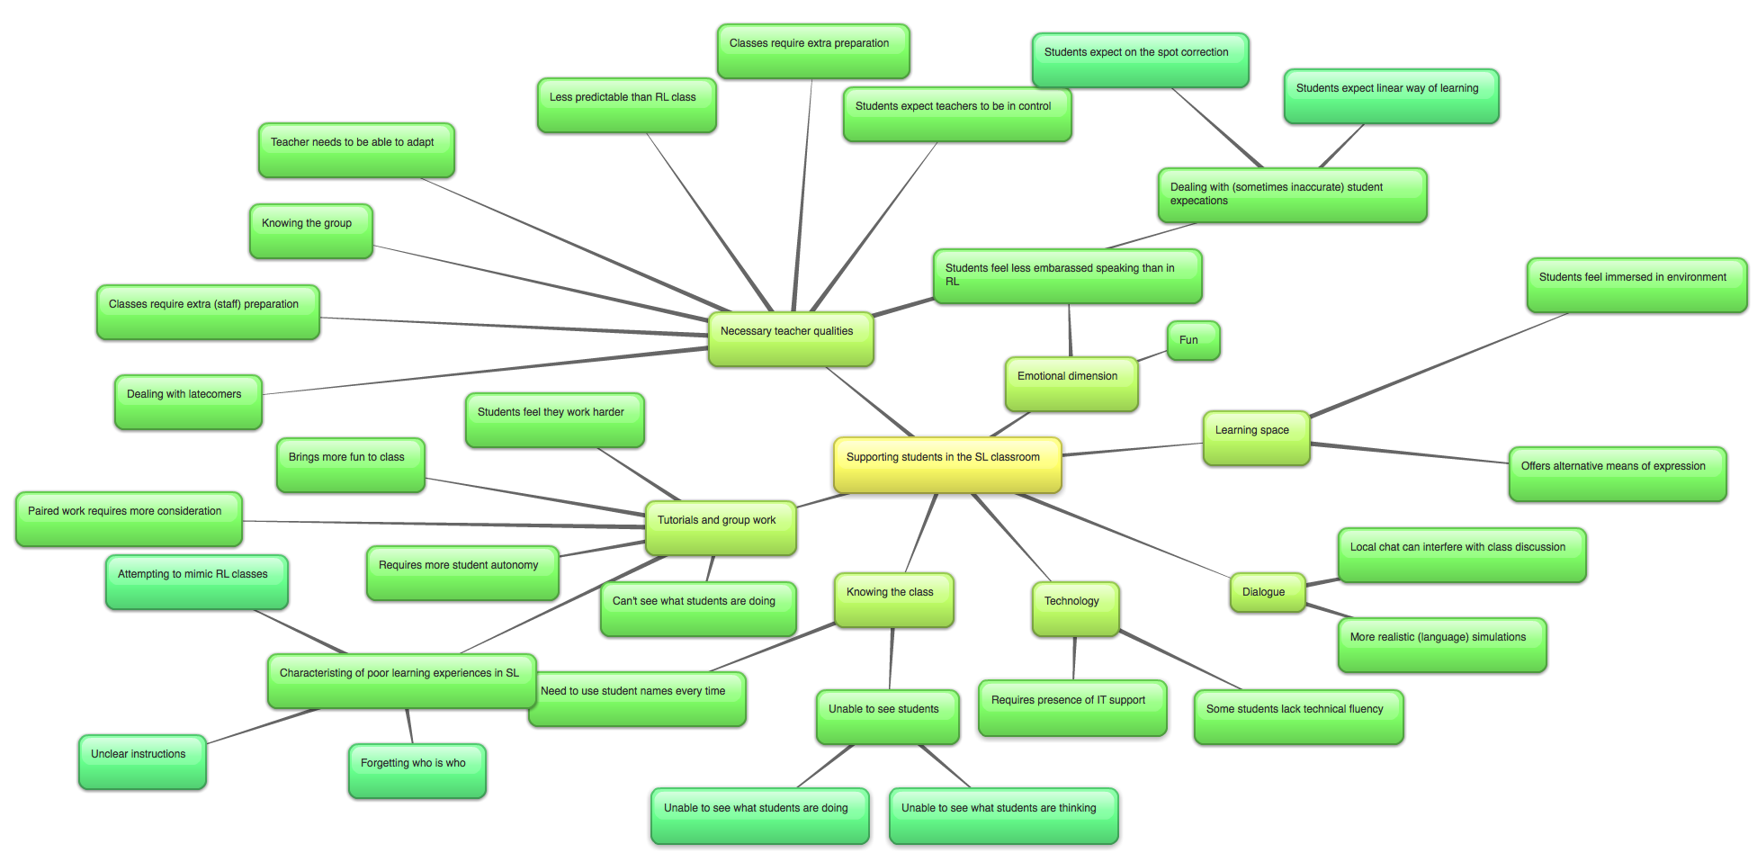
Appendix 1b. Appendix 1a. A visual representation of Joe’s interview

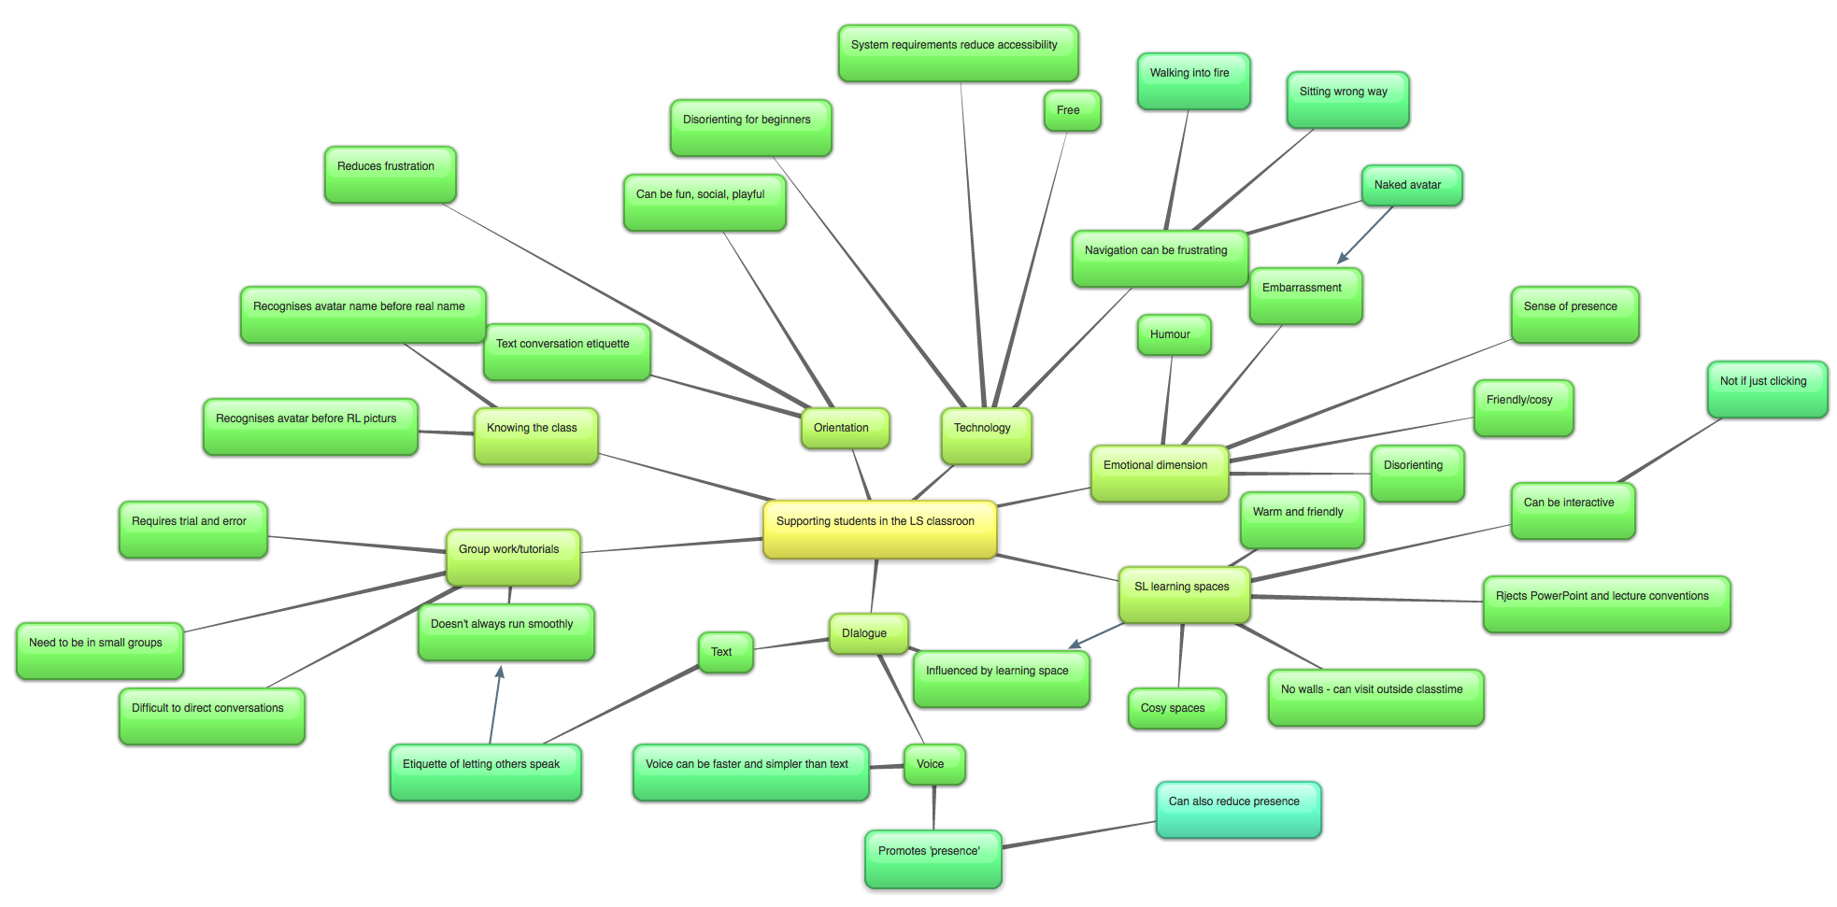
Appendix 2. Establishing groups and codes using the qualitative analysis software HyperRESEARCH
